RASPBERRY PI PICO

What you will do
Connect a Raspberry Pi Pico to another computer and learn how to program it using MicroPython to blink the onboard LED. If you have additional components available, then you can also try out some more examples.
A Raspberry Pi Pico has GPIO pins, much like a Raspberry Pi computer, which means it can be used to control and receive input from a variety of electronic devices.
The new Introduction to Raspberry Pi Pico path uses the picozero package to engage in some creative physical computing projects.
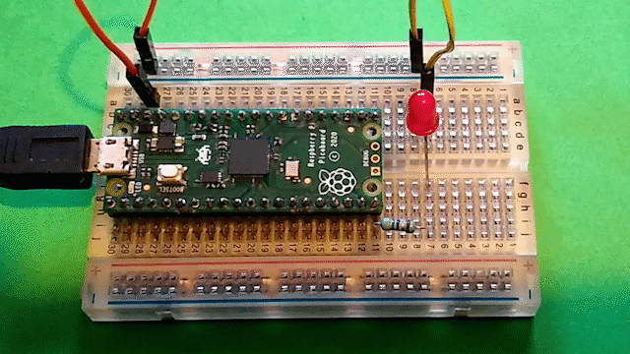

You will need
- A Raspberry Pi Pico
- A computer or laptop
- A micro USB cable

Optional
- A Pico with soldered headers
- A selection of electronics components, such as a button, an LED with appropriate resistor, and a potentiometer
- A breadboard and jumper leads for connecting additional components
- An external 5V micro USB power source.
- This is a Raspberry Pi Pico. Hopefully your device has already had the header pins soldered on, but if not, you might like to have a look at our Getting started with soldering resource.
- 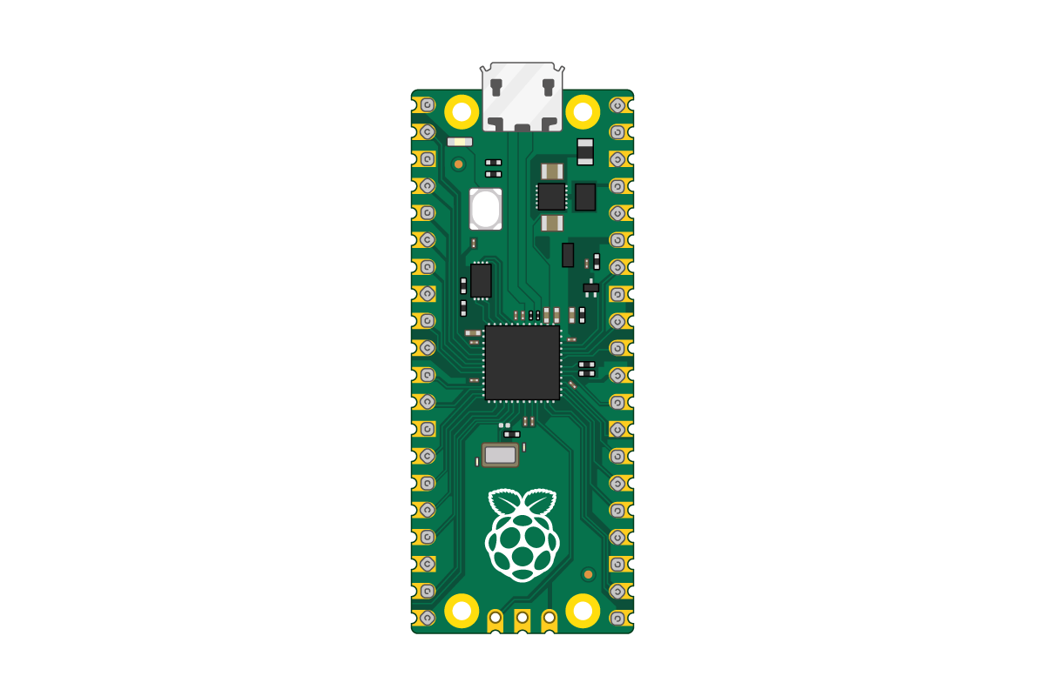
- 
- Plug your micro USB cable into the port on the left-hand side of the board.
- 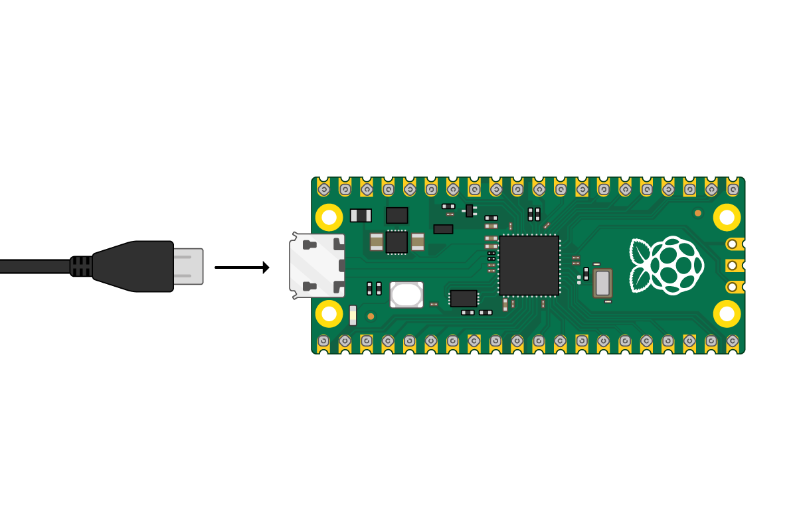
- If you need to know the pin numbers for a Raspberry Pi Pico, you can refer to this diagram.
- 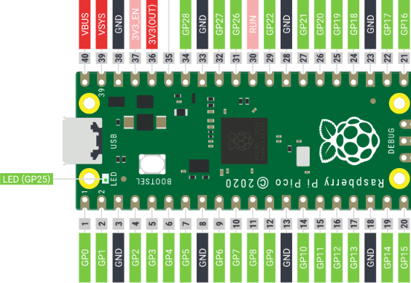
- chevron_leftWhat you will do

Install or update Thonny

Make sure you have the latest version of Thonny.
Thonny is a free and open-source integrated development environment for Python that is designed for beginners.
In a web browser, navigate to thonny.org
In the top right-hand corner of the browser window, you will see download links for Windows and macOS, and instructions for Linux.
Download the relevant files and run them to install Thonny.
Note: Do not open Thonny yet.

Add the MicroPython firmware
Download the correct MicroPython UF2 file for your board:
- Pico
- Pico W
- Pico 2
- Pico 2 W
Find the BOOTSEL button on your Raspberry Pi Pico.
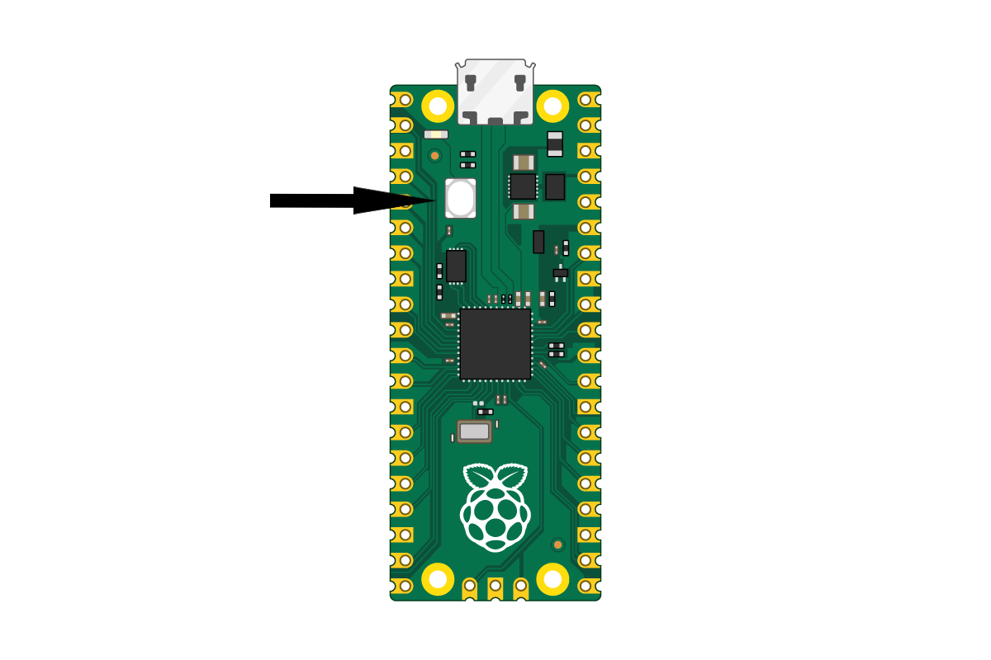
Press the BOOTSEL button and hold it while you connect the other end of the micro USB cable to your computer. A Raspberry Pi is shown in the image below, but the same applies to any computer.
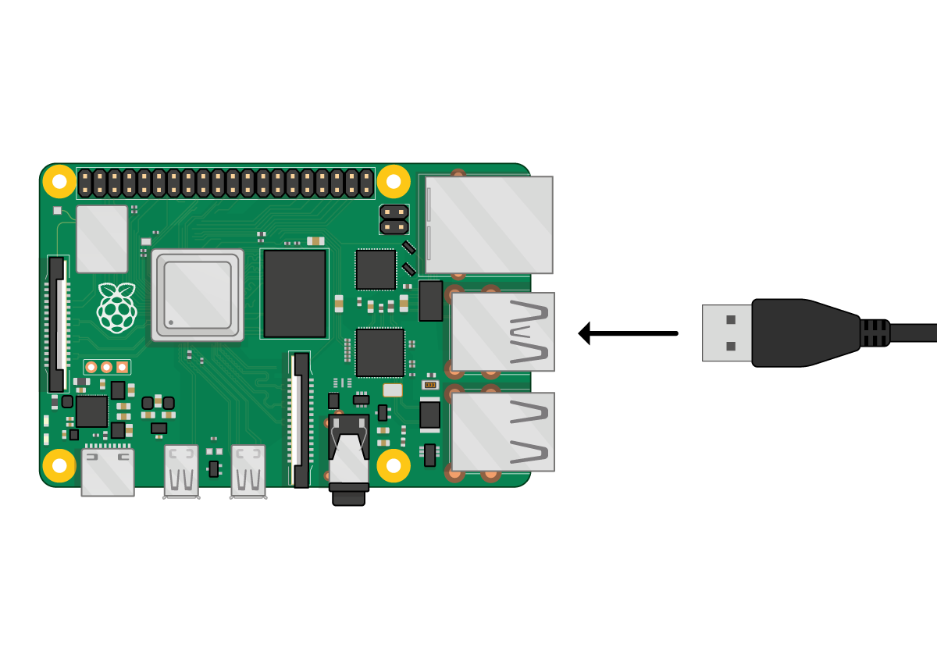
This puts your Raspberry Pi Pico into USB mass storage device mode and the Pico will appear as ‘RPI-RP2’.
Drag and drop the MicroPython UF2 file you downloaded onto the RPI-RP2 volume.
Your Pico will reboot.
Open Thonny. It should look something like this:
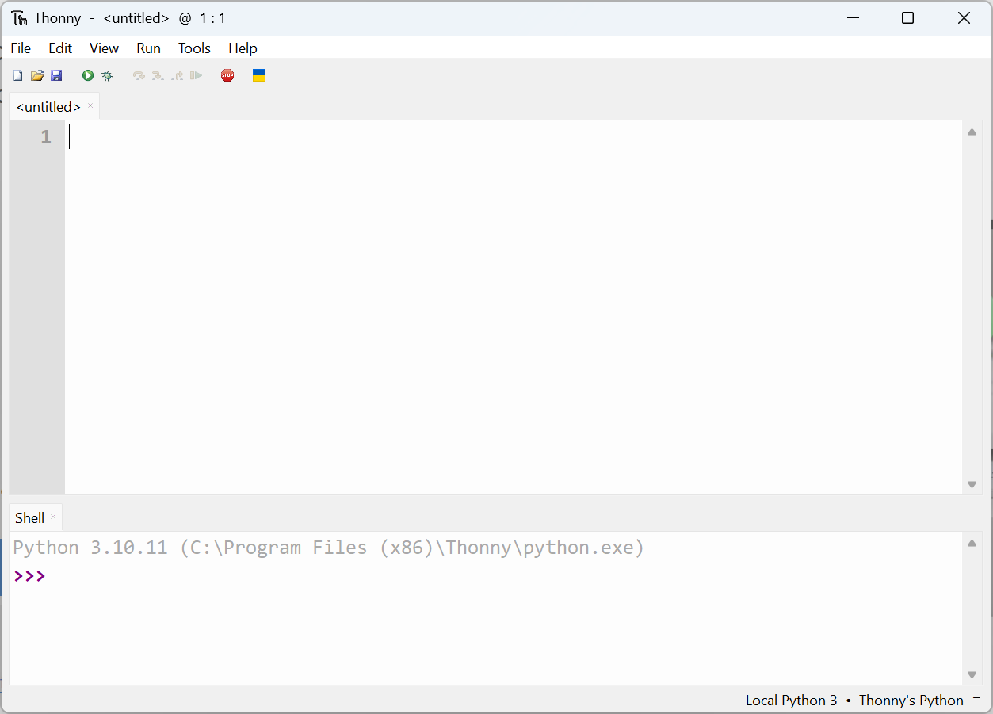
In the bottom right corner of the Thonny window, you will see the interpreter used to run the code you write in Thonny.
By default, Thonny uses the interpreter on the ‘Local’ computer (the one running Thonny).
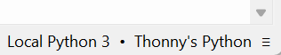
Click the Python interpreter and select MicroPython.
You don’t need to update the firmware every time you use your Raspberry Pi Pico. Next time, you can just plug it into your computer without pressing the ‘BOOTSEL’ button.

Add the picozero package
From Thonny’s ‘Tools’ menu, click ‘Manage packages…’.
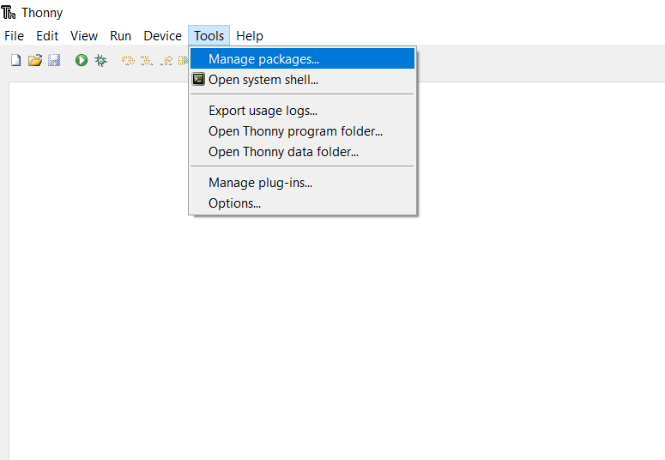
Search for ‘picozero’, then install the package.
Note: You only need to install picozero once.

Blink the onboard LED
Use the Thonny Shell to run some simple Python code on your Raspberry Pi Pico.
Make sure that your Raspberry Pi Pico is connected to your computer and you have selected the MicroPython (Raspberry Pi Pico) interpreter.
Look at the Shell panel at the bottom of the Thonny editor.
You should see something like this:
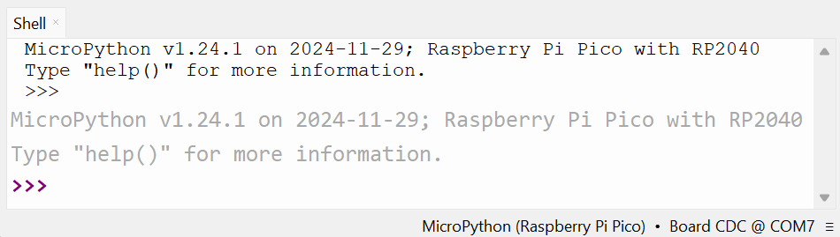
Enter this code in the Shell, making sure you tap Enter after each line.
from picozero import pico_led

pico_led.on()
You should see the onboard LED light up.
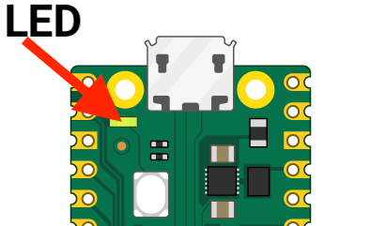
Type the code to turn the LED off.
pico_led.off()
Turn the LED on and off as many times as you like.
Tip: You can use the up arrow on the keyboard to quickly access previous lines.
If you want to write a longer program, then it’s best to save it in a file. You’ll do this in the next step.

Write a longer program
The Shell is useful to make sure everything is working and try out quick commands. However, it’s better to put longer programs in a file.
Thonny can save and run MicroPython programs directly on your Raspberry Pi Pico.
Create a MicroPython program to blink the onboard LED on and off in a loop.
Click in the main editor pane of Thonny.
Enter this code to toggle the LED.
from picozero import pico_led

pico_led.blink()
Click Run and the LED will blink on and off.
Click the Stop button.

Save your program to your Pico
Make sure you have Stopped the program, then click the ‘Save’ icon, or choose ‘Save’ from the ‘File’ menu.
Thonny will give you the option to save the file on This computer, or the Raspberry Pi Pico.
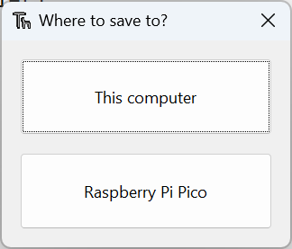
Choose Raspberry Pi Pico.
Enter blink.py as the file name and Click ‘OK’.
Tip: You need to enter the .py file extension so that Thonny recognises the file as a Python file.
Debug: If you get an error saying the device is busy, you need to first ‘Stop’ 🛑 the program running on the Pico.

